The following hand signals for rail operations shall be used in accordance with the Canadian Rail Operating Rules:

MANNER OF USING | INDICATION
Swung from side to side at right angle to the track. | STOP | 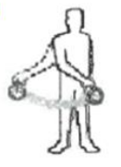
Swung in a circle at right angle to the track at a speed in proportion to the speed required. | MOVE BACKWARD | 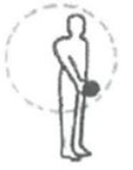
Raised and lowered at a speed in proportion to the speed required. | MOVE FORWARD | 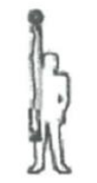
Raised and swung horizontally above the head, at right angle to the track when standing. | APPLY AIR BRAKES | 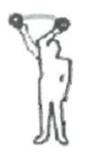
Raised and held at arm’s length above the head when standing. | RELEASE AIR BRAKES | 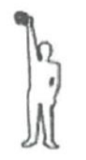
Held horizontally at arm’s length. | REDUCE SPEED | 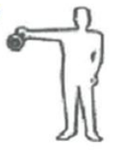
Any object waved violently by anyone on or near the track is a signal to stop. | STOP

