Document Title: Potash Severe Weather Procedure |  | Document Identifier: <Generated by Content Server>
Applies To: Saskatchewan Potash |  | Managed By: EHS PMO
Document Owner: Director, NA Health & Safety Department |  | Document Approver: VP EHS
Current Version Effective Date: | 30 November 2021 | Formal Review Cycle Due Date: | 30 November 2028

Table of Contents

1 PURPOSE 1
2 SCOPE 2
3 GENERAL REQUIREMENTS 2
4 SAFE AREAS 3
5 HIGH WINDS 3
6 EXTREME TEMPERATURE 4
7 TORNADO 4
8 WINTER STORM AND BLIZZARD 5
9 THUNDERSTORM AND LIGHTNING ACTIVITY 5
10 ROLES AND RESPONSIBILITIES 6
11 TRAINING 7
12 DEFINITIONS 8
13 SEVERE WEATHER INSTRUCTIONS 8
14 SEVERE WEATHER EMPLOYEE TRAVEL LOG 14
15 REFERENCES 15

PURPOSE
The purpose of this procedure is to:
- Establish a process for the monitoring of weather conditions at Mosaic Canadian Potash plant sites.
- Establish actions to be taken to ensure personal safety and protect property and equipment from damage or loss during periods of extreme weather.

SCOPE
This procedure applies to all Mosaic Canadian Potash facilities. It contains minimum requirements intended to ensure that all employees and contractors working at these Mosaic facilities are protected from weather extremes.
The established requirements are intended to be followed in the event of abnormal weather conditions, and include parameters for:
- Wind speed
- Extreme temperature
- Winter storm / blizzard
- Thunderstorm/ lightning activity within specified proximity
- Tornado

GENERAL REQUIREMENTS

Mosaic will not permit employees or contractors to place themselves in a position of undue risk by requiring them to report for, or remain at work, without consideration of weather and/or road conditions. Employees must make a reasonable and prudent decision whether to travel to or from work.

Supervisors can use the “Severe Weather Employee Travel Log” (see Section 14) to track and monitor the travel of employees who choose to leave site during a severe weather event in which Mosaic has advised employees to stay at site.

The following are the guidelines for continuous monitoring of the weather 24-hours a day:
Daily Monitoring and Notification Process

Daily Monitoring | - Weather conditions at each Mosaic site will be monitored 24 hours a day using the online IBM Weather Dashboards and the onsite physical weather stations.  - Weather conditions outside of the safe work parameters will be acknowledged and the proper advisory will be issued site wide.  - Security personnel will issue alerts via email to the sitewide email contact group (including contractor group) and audible alerts when applicable when weather reaches the indicated parameters.
During and Post Severe Weather Event
Continuous Monitoring | - Security will monitor the website and weather station for changing conditions and send additional email updates as necessary.
Post Weather Event | - When the weather event has ended, security will send out the “All Clear” template by email to the sitewide email contact group (including contractor group).

Security personnel will monitor the weather conditions at each plant site, refer to the parameters established in this procedure, and issue notifications as necessary via email using the templates set out in the “Severe Weather Alert Instructions” (see Section 13).

Security personnel will broadcast imminent severe weather events (tornado) over the plant site radio, PA system, or via other audible means.

SAFE AREAS

Safe area locations can be found within site EAPs as follows:

Esterhazy Emergency Response Manual – Tab 22

Belle Plaine Emergency Action Plan – Tab 14

Colonsay Emergency Procedures Manual – Tab 12

HIGH WINDS

When sustained wind speeds as per Action Level below are exceeded for 30 minutes, notifications shall be sent out as follows:
Action level | Notification | Note
35 km/h | Work involving the use of man lifts/aerial platforms will be reassessed.  Hoisting/lifting tasks will be reassessed. | If work area is sheltered, aerial work may resume after a safe work plan is generated and Manager approval is granted.
45 km/h | Work involving the use of man lifts/aerial platforms will cease.  Non-urgent hoisting/lifting tasks will cease.
75 km/h | Work involving the use of man lifts/aerial platforms will cease.  Non-urgent hoisting/lifting tasks will cease.  All work on rooftops and inside on elevated galleries will cease.
90 km/h | All employees evacuate to low areas / designated Safe Areas.

Note: Service Rigs shall follow equipment specific procedures and manufacturer recommendations for aerial work in high winds.

Note: Cranes shall follow equipment specific procedures and manufacturer recommendations hoisting/lifting in high winds.

An ALL CLEAR will be issued when sustained wind speeds fall below 35 km/h for 30 minutes.

EXTREME TEMPERATURE

Temperature shall be monitored for both extreme high and extreme low temperatures. Notifications will be issued as follows:
 | Action Level | All Clear
Humidex | 35 C | When temperature falls between the humidex and cold action levels
Wind Chill | - 43 C

All weather exposed non-emergency work will cease during Wind Chill Action Levels.

Refer to the NAB Heat Safety Program for actions to take in extreme high temperatures.

Refer to WorkSafe Saskatchewan’s Working in Cold Conditions for actions to take in extreme cold temperatures.

TORNADO

A Tornado Alert condition will be activated when the following advisories are issued:
Action Level | Notification | All Clear
Tornado Watch | Sitewide Email | When the tornado advisory is cancelled
Tornado Warning | Notification via plant radio, PA system, and/or other audible means.

Security will issue an advisory when a Tornado Watch is issued, that is, when atmospheric conditions are favorable for the development of severe thunderstorms that are capable of producing tornados.

Security shall issue an audible notification to seek shelter / evacuate to a Safe Area when a Tornado Warning is issued, and a tornado is imminent.

WINTER STORM AND BLIZZARD

When weather advisories indicate an approaching severe winter storm or an active blizzard, management will initiate the Emergency Operations Centre (EOC).

Management will issue a communication to all impacted Mosaic employees, depending on the nature of the advisory.

THUNDERSTORM AND LIGHTNING ACTIVITY

When weather advisories or lightning alerts indicate approaching or active thunderstorm/lightning activity as per the Warning and Action Levels indicated below, a site wide notification will be sent out.

Handheld portable lightning detection devices are not permitted as a notification tool.

All outside work shall be re-evaluated. Directions will be provided in the site wide notification.

Thunderstorm and lightning activity shall be monitored, and actions taken when levels at a minimum exceed:
Warning Level | Action Level | All Clear
10 km | 5 km | Greater than Warning Level (10 km) for 15 minutes

Warning Level: Notification that lightning has been detected within the affected area. Employees should stay on alert for additional information and plan to seek shelter in a safe place. Elevated work shall stop. For example:
- Equipment operation on Tailing Management Areas (TMA)
- Operations of mobile cranes / lifting
- Aerial man lifts operations

Action Level: Notification that a lightning strike has been detected within the affected area and all employees shall seek shelter in a safe place. The following activities will be paused, secured and left in a safe state in the event a lightning alert is issued:
- Work being conducted at brine ponds
- Accessing the top of unprotected elevated structures
- Routine electrical work outdoors
- Any Non-emergency work outside of grounded structure or buildings
- Walking in open areas (employees can walk to the shelter)
- Operating an open cab vehicle such as a Utility Vehicle (UTV) (employees can drive to the shelter)
- It is recommended that employees take cover indoors or remain in their vehicle until lightning has passed.

ROLES AND RESPONSIBILITIES

The following table contains a listing of responsibilities for specific groups/jobs as required by this program.
Group or Title | Responsibilities
Senior Management | - Initiate EOC for pending and current severe weather systems as required.  - Communicate with other department managers regarding proceeding actions.  - Notify and advise all individuals in respective departments.  - Ensure compliance with the program requirements at their facility
Superintendents / Supervisors | - Notify and advise all individuals in respective areas of severe weather-initiated actions  - Ensure employees comply with program requirements  - Contact senior management for further direction if required.  - Implement “Bad Weather Travel Log” if required.
Site EHS | - Provide support and subject matter expertise for site implementation  - Work with Supervision as needed to address weather controls
Security | - Ensure continuous monitoring of weather conditions.  - Issue appropriate notifications when weather conditions exceed parameters as per the procedure.
All Employees | - Be familiar and comply with procedure requirements.  - Follow specified instructions regarding personal safety during severe weather events.  - Contact immediate supervisor for further direction.
Contractors | - Be familiar with and comply with procedure requirements.  - Contract supervision - account for all employees and contact Mosaic representative for further direction.  - Contract employees - contact immediate supervisor for further direction.

TRAINING

The following training will be provided for the Severe Weather Procedure:
Audience | Training Elements / Topics | Frequency
Mosaic Employees and Contractors | - Familiarization with the requirements set forth in this procedure in the event a severe weather system occurs. | Initial
Security Personnel | - Roles and responsibilities of this procedure. | Initial

Retraining

In addition, an employee shall receive additional training (or retraining) if any of the following conditions exist:
- Program requirements change;
- Changes in the workplace render previous training obsolete;
- Inadequacies in the employee’s knowledge is of concern
- An incident occurs

DEFINITIONS

Key terms used in this program are defined below.

Term | Definition
Safe Area | Above ground includes a fully enclosed substantial building with plumbing or electrical wiring that will act as a grounding point, or hard top enclosed vehicle / mobile equipment with windows and doors closed. Underground includes basement and tunnel areas.
Elevated Work | Any work that places an employee outside at a raised position including but not limited to cranes, man lifts, etc. including unprotected work above level 1 and / or 4 ft.  The top level of elevated grounded structures.
Humidex | A calculated value that measures how hot we feel by taking into account temperature and humidity in the air. Also described as the “feels like” temperature.

SEVERE WEATHER INSTRUCTIONS

The following templates will be used for Sitewide email notifications:

WIND ALERTS

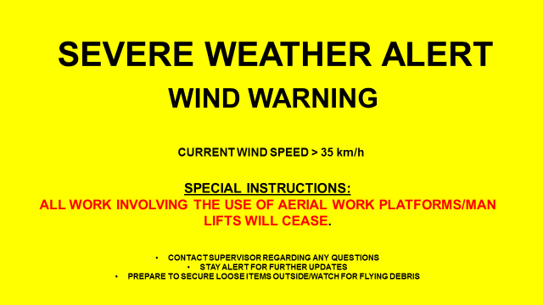
ALL ELEVATED WORK TO BE REASSESSED

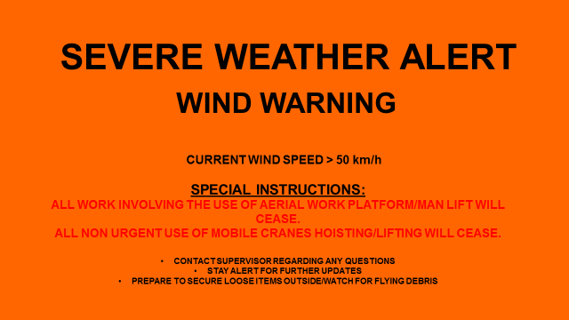
CURRENT WIND SPEED >45 km/h

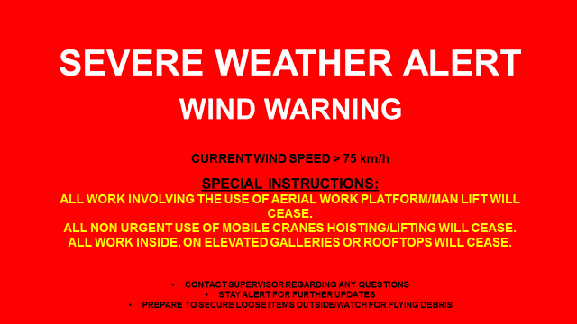

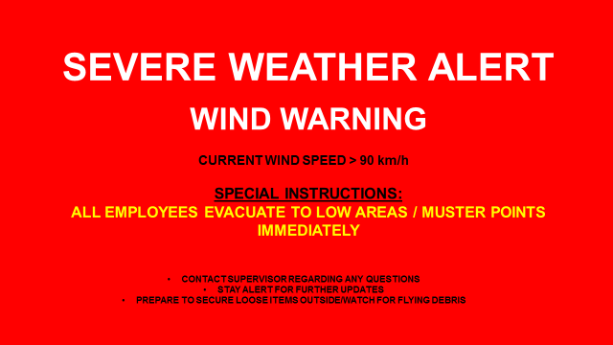
REFER TO SITE EMERGENCY ACTION PLAN IF REQUIRED

LIGHTNING / THUNDERSTORM ALERTS
ACTIVE LIGHTNING <10 KM FROM SITE
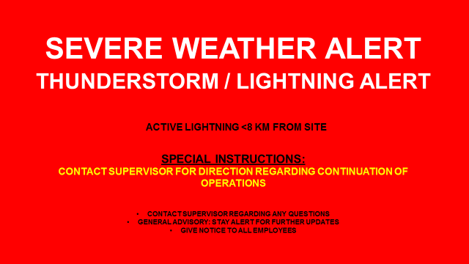
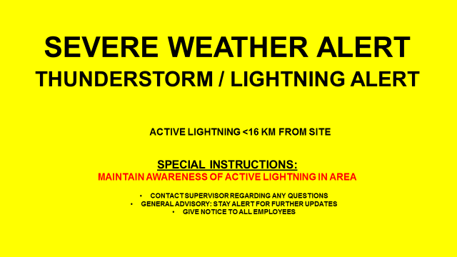
ACTIVE LIGHTNING <5 KM FROM SITE

TORNADO WATCH

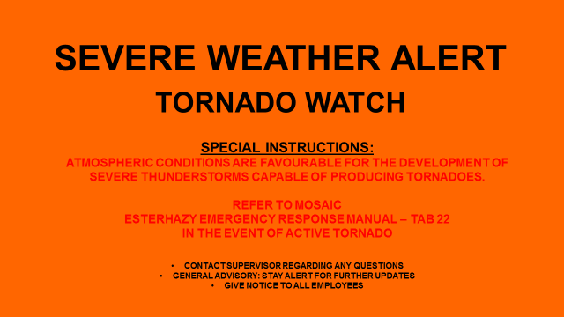
STAY ALERT FOR FURTHER UPDATES

REFER TO SITE EMERGENCY ACTION PLAN IN THE EVENT OF ACTIVE TORNADO

SEVERE COLD
WIND CHILL < -43°C
EXTREME COLD ADVISORY
CONTACT SUPERVISOR FOR DIRECTION
REFER TO HEAT SAFETY PROGRAM
HUMIDEX (FEELS LIKE) 35°C
HEAT ADVISORY

ALL CLEAR (ALL ALERTS)

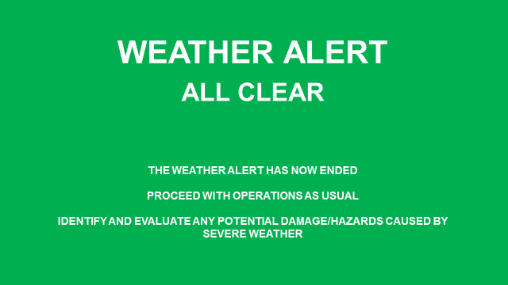

SEVERE WEATHER EMPLOYEE TRAVEL LOG
Driver Name | Passenger Name | Time Leaving Site | Intended Destination | Intended Route | Cell Phone # | Destination Phone # | Destination Arrival Callback Received

REFERENCES
References (Number and title)
Mosaic Record Control Policy
IBM Weather App Quick Start Guide
EHSS NAB Severe Weather Program
Mosaic Esterhazy Emergency Response Manual
Mosaic Colonsay Emergency Procedures Manual
Mosaic Belle Plaine Emergency Action Plan
WorkSafe Saskatchewan - Working in Cold Conditions

