|  |  |  |  |
| --- | --- | --- | --- |
| **Document Title:** Potash Use of Rotary Grinding/Cutoff Tools Program | | **Document Identifier:** <Generated by Content Server> | |
| **Applies To:** North America Potash | | **Managed By:** EHS PMO | |
| **Document Owner:** Director, NA Health & Safety Department | | **Document Approver:** VP EHS | |
| **Current Version Effective Date:** | 17 November 2022 | **Formal Review Cycle Due Date:** | 17 November 2029 |

1. **Purpose / Objective:** This program is intended to provide basic guidelines to ensure that grinding and cutting activities are performed using tools with the best available safety features and that these tools are used in a manner that minimizes risk to employees, contactors, and visitors.
2. **Scope:** This program establishes requirements for the use of handheld, corded electric, battery powered and pneumatic grinders & rotary cutoff tools and applies to all personnel involved with grinding & cutoff activities on Mosaic sites.
3. **Responsibilities**
   1. Mosaic’s representative (employee or authorized contractor) shall ensure that personnel using grinding & cutoff tools**:**
      1. Complete a pre-job hazard assessment before work begins.
      2. Inspect tools before the job begins to ensure all safeguards are functioning. Tag-out any damaged or defective tools.
      3. Follow all safety guidelines for the use of the power hand tools in accordance with the manufacturer’s instructions.
      4. Are competent and trained to operate the tools being used.
      5. Comply with the personal protective equipment (PPE) requirements for using & handling grinding & cutoff tools as defined in Mosaic’s Potash Business Unit PPE Program.
4. **Grinder / Cut-off Tool Specifications:**
   1. **Mosaic accepted tool sizes**
      1. Grinder / Cut-off tools will be limited to those designed for 4.5”/5”, 6” and 9” disk sizes.
         1. 4.5”/5” disks – Can be used for cutting or grinding.
         2. 6” disks – Can be used for cutting or grinding.
         3. 9” disks – Restricted to grinding applications only, not to be used for cutting.
      2. Tools and disks that do not meet this size criteria shall be removed from service unless a specific variance is obtained.
   2. **Grinder / Cut-off Tool Safety Requirements**:
      1. Trigger lock mechanisms that allow the tool to operate without the trigger being continuously pressed by the operator are prohibited. Any tool equipped with such a device shall be removed from service.
      2. If the tool is supplied by the manufacturer with a removable side handle, this side handle shall be installed and used during tool operation. If a specific task cannot be completed with the side handle in place, job specific risk mitigation measures shall be identified on a pre-job hazard assessment and supervisor approval must be obtained and documented before completing the work.
      3. Grinder RPM MUST be visible on the tool so the disc can be properly matched and RPM rating on disk is not exceeded. Tool RPM shall never exceed the RPM rating of the disk being used.
      4. All tools shall be dedicated to either cutting or grinding. Changing guards and disks in the field to switch between grinding and cutting applications is prohibited.
      5. Cutting Guard – All tools used for cutting must have, at a minimum, a dedicated half clamshell cutting guard. An example of an acceptable cutting guard is shown in Figure 1 below.

**Figure 1**

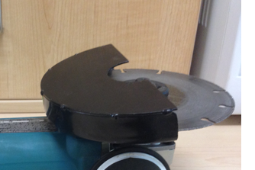

* + 1. Grinding Guard – All tools used for grinding must have, at a minimum, a dedicated open face grinding guard. An example of an acceptable grinding guard is shown in Figure 2 below.

**Figure 2**

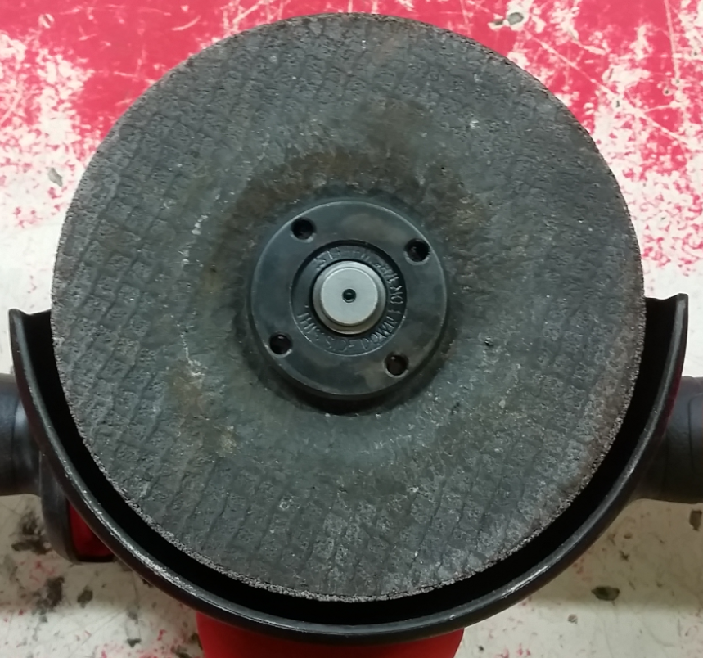

* + 1. **Corded electric tools must be equipped with the following safety features:**
       1. Two stage safety trigger that minimizes the risk of unintentional depression of the trigger.
       2. Mechanical braking device designed to prevent free spinning of the disk upon release of the trigger.
       3. Clutch designed to minimize unintentional binding of the disk and grinder kickback.
    2. **Battery powered tools must be equipped with the following safety features:**
       1. Two stage safety trigger that minimizes the risk of unintentional depression of the trigger.
       2. Electric disk brake designed to reduce the duration of disk rotation upon release of the trigger.
  1. **Grinder Cutting Disks** 
     1. All cutting disks must have a minimum thickness of 5/64”, with the exception of metallic diamond cutting disks, which must have a minimum thickness of 3/64”.
     2. Examples of acceptable cutting disks are shown in Figure 3 below.

**Figure 3**

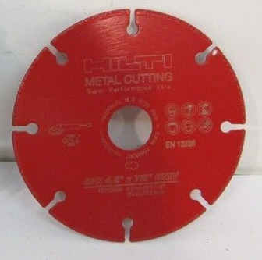

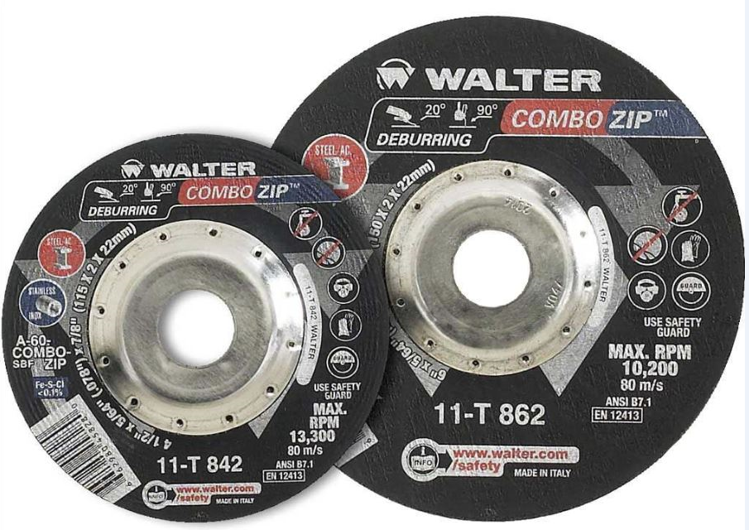

Example of carbon fibre cutting disk Example of metallic diamond cutting disk

1. **References:**
   1. [Mosaic's Potash Business Unit PPE Program](https://doculink.mosaicco.com/livelink/llisapi.dll?func=brava.bravaviewer&nodeid=18158379&vernum=0&OpenInNewWin=_blank&NewWinParam=resizable)