|  |  |  |  |
| --- | --- | --- | --- |
| **Document Title:** Potash Use of Personal Protective Equipment Program | | **Document Identifier:** <Generated by Content Server> | |
| **Applies To:** North America Potash | | **Managed By:** EHS PMO | |
| **Document Owner:** Director, NA Health & Safety Department | | **Document Approver:** VP EHS | |
| **Current Version Effective Date:** | 14 November 2023 | **Formal Review Cycle Due Date:** | 14 November 2030 |

**Background**

Purpose

In Scope

Out of Scope

**General Requirements**

Minimum Requirements

Selection

Care and Inspection

When is Specialty PPE Required

Variations and Exceptions from Program

Training

Evaluation of Effectiveness of PPE Program

**Contractor, Visitor, Trucker and Delivery Personnel PPE**

**Jewelry**

**Hair and Facial Hair**

**Protective Clothing**

**Head Protection**

**Eye and Face Protection**

**Hearing Protection**

**Foot Protection**

**Hand Protection**

APPENDIX A – Overview of Mosaic Potash Business Unit (PBU) minimum PPE requirements

APPENDIX B - Personal Protective Clothing for all Mosaic Employees

APPENDIX C - Filter Lenses for Protection against Radiant Energy

APPENDIX D - Glove Selection

**APPENDIX D-1 - Glove Selection Guide**

**APPENDIX D-2 - Gloves Types and Construction**

### Background

|  |  |
| --- | --- |
| Purpose | To ensure that anyone working or visiting a MosaicPotash Site can select and maintain the minimum required Personal Protective Equipment (PPE). |

|  |  |
| --- | --- |
| In Scope | This program applies to anyone while on Mosaic sites. |

|  |  |
| --- | --- |
| Out of Scope | Some trades or tasks require additional or specialized PPE, which will not be covered in this document, such as:   * Electricians * Welders * Chemists * Mine Rescue/ Emergency Response Personnel when actively responding to an emergency * Working at heights |

### General Requirements

|  |  |
| --- | --- |
| Minimum Requirements | PPE Required Areas Anyone within a PPE required area must wear, at a minimum, the following “*Standard PPE*”:   * Hard hat * Safety glasses * High visibility clothing * Safety boots with internal metatarsal protection * Gloves   icon_note.png ***Note***: Hearing protection must be worn in areas with noise levels above 85 (dB) decibels. |

|  |  |
| --- | --- |
| Modified PPE Areas and PPE Free Zones | Based on hazard assessment, sites may establish clearly marked, designated Modified PPE Areas and PPE Free Zones.   * Modified PPE Areas are low hazard work areas where Standard PPE is not necessary, but some PPE is required to mitigate specific hazards. Quality Control Labs are a common example of a Modified PPE Area. * Work areas designated as PPE Free Zones are areas where no specific PPE requirements apply. Street clothes, compliant with the site’s Dress Code Program are approved to be worn in PPE Free Zones. |
|  |  |
|  |  |

|  |  |
| --- | --- |
| Working in Modified PPE Areas and PPE Free Zones | Anyone performing trades type activities (plumbing, electrical, carpentry, etc.) within PPE Free Zones or Modified PPE Areas must wear at a minimum the *Standard PPE*.  Anyone performing non-trades type activities within PPE Free Zones that may introduce a hazard that can only be mitigated by PPE must wear the appropriate PPE as deemed necessary. Hazards can be identified by conducting a *Hazard Assessment* (i.e. Field Level Hazard Assessment-FLHA/Job Hazard Assessment-JHA). |

|  |  |
| --- | --- |
| Selection | All PPE must be of a safe design and construction for the work to be performed.  All PPE must meet or exceed at least one of the following standards:   * CSA – Canadian Standards Association * ANSI – American National Standards Institute * NIOSH – National Institute for Occupational Safety and Health * DOT- Department of Transportation * Note: All recommendations for new PPE must follow the approved Procurement process.   sign_warning.png ***Warning:*** All PPE that is acquired or provided by employees that is not a company approved item must be approved prior to use by the Manager of Environment, Health, Safety, and Security or their designate. |

|  |  |
| --- | --- |
| Care and Inspection | Inspection All PPE must be inspected prior to each use to ensure it is fit for purpose and meets the basic requirements of the manufacturer.  When PPE is found to be in questionable condition during a task, a *Hazard Assessment* must be performed to confirm the PPE is in satisfactory condition to continue working.  icon_note.png Note: PPE that fails the inspection must be removed from service immediately and replaced. Care All PPE must be maintained as per manufacturer’s recommendations. |

|  |  |
| --- | --- |
| When is Specialty PPE Required | Additional or specialized PPE must be worn if engineering and administrative controls do not provide adequate protection from hazards that can cause injury or impairment in a function of any part of the body through absorption, inhalation or physical contact. Some trades such as welders, electricians, chemists, seismic crews etc. will have to don additional or specialized PPE.  For example, hazards that will require additional or specialized PPE may include:   * Chemicals * Radiation * Mechanical * Biological * Warning: Anyone accessing the underground mine areas must at all times have a W65 (or similar) self-rescue breathing apparatus readily accessible. |
| Hazard Assessments | The following are acceptable methods of determining what additional PPE may be required:   * Field Level Hazard Assessment (FLHA) * Job Hazard Assessment (JHA) * Touring and visual inspection of entire work area * Interviewing employees familiar with the task * Reviewing Safety Data Sheets (SDS) * Reviewing accident/injury data * Risk Register |

|  |  |
| --- | --- |
| Flotation Devices | Approved flotation devices must be used when working on or near bodies of water and there is a risk of falling and drowning as per the Mosaic “Working Around Water Standard”. |

|  |  |
| --- | --- |
| Variations and Exceptions from Program | Any variance to this program must be:   * Risk assessed; and * Time limited; and * Approved by the site EHSS Manager and/or either the applicable GM or Capital Director * Documented using the Variance Form in Appendix E |

|  |  |
| --- | --- |
| Training | All employees required to wear PPE must be trained on proper selection, use and care for the PPE. Retraining Retraining should be provided when:   * New PPE is introduced to the workforce * Employees are observed using PPE improperly  Training Documentation Training on the use of PPE should be documented either on its own or part of a broader training program such as an orientation. |

|  |  |
| --- | --- |
| Evaluation of Effectiveness of PPE Program | The PPE Program will be reviewed every three years or when changes are required by the EHSS Department. The review must include an:   * Overview of workplace hazard assessments to ensure they are current and complete * Overview of any new processes to the facility to ensure all necessary PPE has been purchased and implemented * Review of Program and MMS for accuracy and compliance with any new or amended government or corporate standards * Review of past incidents to identify areas where PPE would be introduced to prevent re-occurrence. |

### Contractor, Visitor, Trucker and Delivery Personnel PPE

|  |  |
| --- | --- |
| Contractor Requirements General Requirements | All contractors’ PPE must meet or exceed all of the requirements as set out by this document. Short Term Contractors Short Term Contractors’ clothing:   * May be any color, so long as the clothing meets CSA High Visibility Class 1 requirements. * Flame Resistance and Arc Flash Protection that meets or exceedsthe requirements of this document will only be necessary based on a Job Hazard Assessment of the tasks being performed.   information2.png Information: Short Term Contractors shall constitute any firm that will be working on site for less than 6 consecutive months. Long Term Contractors Long term contractors’ clothing must meet or exceed:   * CSA High Visibility Clothing Class 2 requirements. * Flame Resistance and Arc Flash Protection that meets or exceeds the requirements of this document.   information2.png Information: Long Term Contractors shall constitute any firm that will be working on site for at least 6 consecutive months. Contractor Hard Hats Contractor’s hard hats may be any color **(except red)** so long as they meet the standards per this document.  icon_note.png Note: Red hardhat color has been reserved for Mine Rescue and Surface ERT members to provide site personnel with instant recognition of response members. |

|  |  |
| --- | --- |
| Visitor Requirements | All site visitors that will be accessing a PPE required zone must either bring or be supplied with PPE that meets or exceeds the requirements in this document.  Site visitors must wear the following PPE when entering PPE required areas:   * Orange hard hat * Safety glasses must be half or full seal glasses or goggles * Steel toed boots with metatarsal protection * High visibility clothing or break-away vest that meets CSA Class 1 or equivalent * Gloves * Hearing protection when in areas with noise levels above 85 dB   icon_note.png Note: Visitors in general are defined as anyone that will not be paid or perform any work while on site.  icon_note.png Note: Mosaic employees are considered visitors unless they have valid local site employee or contractor orientation.  icon_note.png Note: Visitors with prescription eyewear will be supplied with a pair of full seal “Over the Glasses” (OTG) goggles if their personal eyewear does not qualify as full or half seal. |

|  |  |
| --- | --- |
| Trucker, Couriers and Delivery Personnel Requirements | Delivery personnel and truckers require the following PPE when accessing PPE areas at the site:   * Hard hat * Half or full seal safety glasses * High visibility clothing or break-away vest that meets CSA Class 1 or equivalent * Gloves * Approved safety boots   icon_note.pngNote: Sites may establish a PPE free or modified PPE zones as appropriate based on a risk assessment. All such zones must be well defined and clearly marked. |

### Jewelry

|  |  |
| --- | --- |
| Approved Jewelry | The following items of jewelry are permitted within PPE required areas so long as they do not interfere with the PPE or pose another hazard:   * Stud type earrings * Stud type facial piercings * Non visible body piercings * Solid ear lobe disks * Medical Alert bracelets, if they possess a break-away clasp or strap. * Watches that possess bands held in place by pins * Lanyards used to carry keys, ID, memory cards, etc. if they possess a break-away clasp   icon_note.png Note: Break-away clasp can be any clasp that by design is weaker than the actual chain, strap or lanyard. This may consist of a weak pin, loop, mechanical clasp, etc. |

|  |  |
| --- | --- |
| Prohibited Jewelry | The following items of jewelry are prohibited in areas that require PPE:   * Rings * Bracelets (see note on Medical Alert bracelets above) * Necklaces * Dangly, welded or solid hooped, or partially hooped piercings * Open ear lobe disks   icon_note.png Note: If open ear lobe disks or open ear lobes are present, they must be taped when entering a PPE zone. |

### 

### Hair and Facial Hair

|  |  |
| --- | --- |
| Length of Hair | Hair cannot extend below the base of one’s collar. Hair longer than the base of the collar must be confined using one of the following or similar approved methods:   * Dew-rag (must be snug and the knot cannot exceed one’s collar) * Welder’s hat * Hair band(s) * Bobby pin(s)   icon_note.png Note: A hard hat is not considered an approved method for containing one’s hair above the bottom of their collar. Hair must remain contained even with one’s hardhat removed. |

|  |  |
| --- | --- |
| Length of Facial Hair | Beards, goatees, mustaches and sideburns must be kept trimmed or secured to a maximum length of two (2) inches. Facial hair longer than two (2) inches must be contained by employing a beard net, hair band(s) or other approved means.  icon_note.png Note: Employees who could be required to wear a respirator during a day where a tight fit is essential to the proper functioning of the respirator must be clean shaven. |

### Protective Clothing

|  |  |
| --- | --- |
| Minimum Standards | All Mosaic employees must wear the provided uniform coveralls or pants and shirt when entering a PPE required area. Clothing must meet or exceed the following standards:   * CSA Z96-15 or ANSI 107-2015 Class 2 for high visibility apparel * Flame Resistant (FR Rated) * Arc Flash rated to a minimum of Arc Thermal Protection Value (ATPV) of 8 calories/cm2 * Tops must be long sleeved (Coveralls, t-shirts, shirts)   + Shirts must be either tucked into pants or contained with a belt to ensure an employee is protected in the case of an Arc Flash blast * Shirts and coveralls must be buttoned/zipped up to at least the neckline * Pants must be full length   + No cuffs on pants if performing hot work. * Outer wear (Jackets, Parkas, vests, etc.) must meet or exceed these standards, unless the greatest hazard associated with the work being performed can be more effectively mitigated by using a different type of outer wear. Any deviation from standard outer wear must be identified and justified on a Field Level Hazard Assessment (FLHA) or Safe Work Permit (SWP). * All hoods, including those attached to Hoodies (aka “Bunny Hugs”) or hooded jackets/parkas must:   + Be designed to break away from the clothing if caught or pulled (breakaway hoods).   + Not have a drawstring. If hood is supplied with a drawstring, the drawstring must be removed prior to use in a PPE area.   + Be worn in such a manner that peripheral vision is not obstructed.   sign_warning.png ***Warning:*** Sleeves shall be rolled up when using lathes to prevent them from getting entangled.    icon_note.png Note: The continued use and purchase of Mosaic specification royal blue Class 1 visibility winter parkas is approved due to availability and suitability concerns with the Class 2 yellow parkas. This condition is subject to future change if we can improve the warmth and availability of the yellow parka option. |
|  |  |

|  |  |
| --- | --- |
| Disposable Coveralls | Disposable coveralls (i.e. Tyvek style) may be worn on top of PPE clothing when there is a need to protect the clothing from the work environment. In these situations a documented hazard assessment must be completed to ensure that the coveralls do not introduce a new risk such as entanglement.  sign_warning.png Warning: These must not be used during jobs that involve Hot Work or the risk of an Arc Flash. |

|  |  |
| --- | --- |
| High Visibility Vests | All high visibility vests must be of the break-away style to ensure that they do not become an entanglement hazard. |

|  |  |
| --- | --- |
| Alterations to clothing | Alterations such as hemming pants for length, replacing buttons, repairing of rips, and patching holes is permitted, however, these alterations must be performed by a vendor that has the appropriate supplies i.e. FR thread and FR patches. |

|  |  |
| --- | --- |
| Prohibited Clothing | The following items are prohibited from being worn within areas that require PPE:   * Short sleeves   + Long sleeves must be worn and cannot be rolled up * Shorts or Cut Offs   + Pants must cover entire leg and leave no exposed skin * Loose Clothing   + Scarves   + Jackets/Parkas with non-detachable hoods |

### Head Protection

|  |  |
| --- | --- |
| Minimum Standards for Hard Hats | Hard hats must meet or exceed the CSA Z94.1-15 or ANSI 289.1-2014 requirements for Class G and E (or equivalent standard).  icon_note.png Note: Existing Class C hard hats (V-Gard hardhats with UG light clip holders) must be replaced with Class G or E hard hats in accordance with their scheduled replacement over the next 5 years. Labels Hard hats must have a label applied to the front of the hardhat which indicates the employee’s first and last name. Nicknames may also be applied so long as the first and last names are visible. Suspension Systems Hard hats must have suspension systems properly installed and worn peak forward.  icon_note.png Note: Hard hats may be worn peak backwards only during welding, grinding or climbing activities. These hard hats must be specifically designed and approved by the manufacturer to be worn in reverse. Alternations It is specifically prohibited to do any of the following activities to a hard hat:   * File * Drill * Saw * Cut * Apply any type of coating or paint   Hard hat suspensions and liners must be maintained in good condition. Alterations are prohibited. |

|  |  |
| --- | --- |
| Hard Hat Colors | The following are the assigned hard hat colors for Mosaic employees:   * White – Mosaic Employees * Red – Emergency Response Team/Mine Rescue members * Green – New hire employees (less than 90 days) * Orange – Visitors and Truckers/Delivery Personnel   icon_note.png Note: Contractors may wear any color (**except red)** which has been designated for Mine Rescue and Surface Emergency Response team members. |

|  |  |
| --- | --- |
| Decals | Hard hats may only be decorated or modified by the application of self-adhesive decal(s) that are approved by management. Decals must not be located within ½” of the rim of the hard hat.  sign_warning.png Warning: No metallic stickers may be affixed to a Class “E” hard hat. |

|  |  |
| --- | --- |
| Hard Hats in vehicles | Open Cab Vehicles Employees operating or riding in mobile equipment without fully enclosed cabs (i.e. skid steers, forklifts, golf carts, mobile cranes, etc.) must wear an approved hard hat. Fully Enclosed Cab Vehicles Employees are not required to wear hard hats, but must have a hard hat in their possession in the following circumstances:   * When operating or riding in the cab of a pick-up truck, service truck, semi-tractor, automobile or equivalent vehicle with overhead protection in PPE required areas * When operating or riding in a fully enclosed cab of a tractor (crawler or rubber tired) frontend loader or locomotive with overhead protection.   Note: Fully enclosed is a cab equipped with doors, roof, windows and sides that will prevent the outside atmosphere from entering the operator’s compartment.  ***Note:*** Employees in a fully enclosed cab with windows open are not required to wear a hard hat but must wear approved safety glasses. |

|  |  |
| --- | --- |
| Inspection and replacement | Hard hats and suspension systems must be inspected before each use. Damaged or deteriorated items must be replaced immediately. At a minimum hard hats must be replaced every 5 years and suspension systems on an annual basis.  information2.png Information: Hard hats that have received a significant blow must be replaced even if no visible damage is noted |

|  |  |
| --- | --- |
| Liners | Snug fitting welder’s caps, kerchiefs, cooling rags and winter liners may be worn under the hard hat suspension as long as it doesn’t interfere with the fit of the hard hat.  sign_warning.png Warning: Ball caps are prohibited from being worn in conjunction with a hard hat. |

|  |  |
| --- | --- |
| Chin Straps | Chin straps and other approved devices should be employed where conditions may cause the hard hat to be dislodged. For example, in windy conditions when working at heights. |

|  |  |
| --- | --- |
| Underground Cap Lamp | Anyone accessing the underground mine areas must at all times have a functional cap lamp attached to their hardhat. |

|  |  |
| --- | --- |
| Motor Vehicle Helmets | United States Department of Transportation (DOT) approved helmets with a face shield must be worn in lieu of a hard hat for any work requiring the use of an All-Terrain Vehicle (ATV) or snowmobile. |

### 

### Eye and Face Protection

|  |  |
| --- | --- |
| Minimum Standards for Safety Glasses | All safety glasses (prescription and non-prescription) must meet or exceed the requirements of CSA Standard Z94.3-02 or ANSI Z87.1 (or other equivalent standard).  At all operating sites, full seal or half seal safety glasses must be worn at all times when in a PPE required area. Specific groups may mandate full seal glasses based on increased hazards associated with the type of work that is commonly performed.  icon_note.png Note: Anyone in close proximity to employees performing work requiring specific eye protection must also wear the specified eye protection. |

|  |  |
| --- | --- |
| Lens Tint | Safety glasses must have clear (no tint) when underground or indoors.  On surface, safety glasses with dark tinted lenses for exterior sun protection may be worn during daylight hours.   * Employees who wear dark tinted lenses must carry a pair of clear safety glasses with them at all times   information2.png Information: Daylight is defined as 30 minutes after sunrise and 30 minutes prior to sunset  sign_warning.png ***Warning:*** Mirrored safety glasses are not permitted on sites.  icon_note.png Note: Self darkening (Transition) lenses are approved for use in PPE required areas, but sites shall exercise discretion when providing authorization for employees to purchase transition lenses. It is the responsibility of the individual to allow their eyes and eyewear time to adjust to changing lighting conditions before resuming work. |

|  |  |
| --- | --- |
| Contact Lenses | Contact lenses are prohibited in areas that require PPE. |

|  |  |
| --- | --- |
| Safety Glasses in Vehicles | Open Cab Vehicles Employees in mobile equipment without a fully enclosed cab (skid steer, forklift, golf carts, etc.) OR in fully enclosed cab with windows or doors open must wear approved safety glasses. Closed Cab Vehicles Employees operating or riding in mobile equipment with fully enclosed cabs (trucks, semi-tractors, etc.) may remove their safety glasses so long as the windows and doors are closed. |

|  |  |
| --- | --- |
| Face Shields, Welding Helmets, and Goggles | Face Shields with Safety Glasses / Goggles Face shield with approved safety glasses **or** face shield with full seal goggles with a properly adjusted elastic strap must be worn in the following circumstances:   * When operating portable or bench grinders * When using a hot stick to operate high voltage-fusible disconnects * When abrasive blasting (sandblasting, soda blasting, etc.) * Whenever the job has the potential risk of flying debris, chips or sparks * When handling chemicals, or operating valves on systems containing chemicals. Refer to SDS for further guidance. * When using circular and chop saws   Face shields **and** approved full seal goggles with a properly adjusted elastic strap must be worn in the following circumstances:   * When handling acids, alkalis or other chemicals that have the potential to cause immediate or acute damage to eyes or skin upon exposure. * When performing overhead work involving cutting, drilling, grinding or abrasive blasting * When performing cutting, grinding or abrasive blasting in a confined space * When using compressed air at a pressure of 45 PSI or more, for housekeeping or cleaning activities * When performing bulk chemical loading and offloading activities. (This does not apply to fueling vehicles or equipment.) * When pressure washing. * Note: Pressure washing is the act of using water or other fluid pressurized by mechanical means such as a pump for cleaning or housekeeping purposes. Using water hoses and nozzles at standard plant pressures with no supplemental pressurization is not considered pressure washing.   Full seal goggles with a properly adjusted elastic strap must be worn in the following circumstances:   * When performing outdoor work in sustained wind more than 50 km/hr. * When mixing or transferring grout, cement or other very dusty materials * Note: Positive Air Purifying Respirators (PAPR) and Supplied Air respirators provide a higher level of protection and may be used in lieu of the requirements above. * Note: Full seal safety glasses with a properly adjusted elastic strap meet the requirement for full seal goggles, provided the eyewear provides a complete seal against the skin.  Welding Hoods/Helmets Welding hoods or helmets must be worn while performing any type of electric welding operation.  information2.png Information: See Appendix A for a complete guideline on welding eye protection.  icon_note.png Note: Safety glasses or goggles must be worn under face shields and welding hoods/helmets at all times.  Note: Mesh face shields may be used with the appropriate approval and hazard assessment. |

### 

### Hearing Protection

|  |  |
| --- | --- |
| Minimum Requirements for Hearing Protection | All hearing protection devices must meet or exceed the requirements of CSA Z94.2-14 or ANSI 512.6-97.  The noise reduction available from a hearing protection device is an intrinsic property of the device and may be affected by:   * Correct fit * Adequate attenuation * Over protection * Comfort * Working conditions |
| Fitting Devices | In order to be effective, hearing protection must provide adequate noise reduction and be worn as designed by the manufacturer.  Instruction and demonstration on how to effectively fit hearing protectors will be provided on commencement of employment and as necessary by Occupational Health Nurse staff. |

|  |  |
| --- | --- |
| Wear Time | Hearing protection must be worn at all times when the noise level is greater than 85 decibels (dB).  Areas with noise levels above 105 dB require double hearing protection (Ear plugs plus ear muffs). These areas are to have signage to indicate the noise levels and the requirement for double hearing protection. |

|  |  |
| --- | --- |
| Maintenance of Hearing Protection Devices | Hearing protectors must be maintained in a clean and hygienic condition.  Hearing protectors must be inspected prior to each use. |

|  |  |
| --- | --- |
| Hearing Protection Areas | Some examples of areas that must be designated as “Hearing Protection Areas” include:   * All surface buildings containing potentially high noise   + Process Plant (Mill/Refinery)   icon_note.png Note: Mills/Refinery will not be exempt during Shut Down days   * + Power House   + Load Out   + Maintenance Shops * Mobile equipment with noise levels above 85 dB * Underground Workshops * Underground when travelling from one work area to another   icon_note.png Note: Once at the new work area, re-assess the noise levels to determine the need for hearing protection   * When working in an area that has high noise emitting equipment (temporary or permanent) |

### Foot Protection

|  |  |
| --- | --- |
| Minimum requirements for Foot Protection | Safety boots must meet or exceed the requirements of CSA Z195-M92 or ASTM 2413-11Mt.  All safety boots must be at least 8” tall and must have internal metatarsal protection except as described in the note below. If the manufacturers’ specifications state that it is an 8” boot then they qualify for Mosaic’s foot protection program. Boots manufactured from leather, rubber or chemical resistant materials are acceptable.  Lace up boots must be laced to the top of the boot (top grommet or eyelet). |
|  | * Note: “Lace in” metatarsal guards are allowed for low risk activities, such as tours or visual inspections. |

#### 

### Hand Protection

|  |  |
| --- | --- |
| Minimum Hand Protection requirements | Employees must at all times, when in a PPE required area, wear a pair of gloves suitable for the task.  Gloves may be removed in the following situations without a documented risk assessment:   * Personal hygiene activities * Eating in break areas that are in PPE required zones (such as underground) * Installing earplugs, cleaning glasses or adjusting other PPE that may not be easily done with gloves on. * Using authorized electronic devices, such as cameras, phone or surveying equipment * Use of lathes * When inside enclosed mobile equipment * Handling of small/fine parts which pose no hazards, such as tiny screws.   icon_note.png Note: Gloves with drawstrings must have the string removed.    icon_note.png Note: Gloves may be removed in other situations, but only when a documented risk assessment (FLHA, JHA, etc.) has been performed and it can be shown that the gloves introduce more risk than they mitigate.  icon_note.png Note: Gloves must be worn when using stairs in PPE areas, as handrails could have rough surfaces that may create a hazard.  information2.png ***Information:*** Refer to Appendix D for more detail on Glove Selection. |
|  |  |

|  |  |
| --- | --- |
| Responsibilities | **Supervisors**   * Model good work practices by consistently and properly wearing the right gloves for the job. * Participate in educating and training workers about the hazards in the workplace, how gloves protect the worker, how to wear them correctly, when they must be worn, how to maintain, store, and dispose of them properly. * Check that gloves are available and that workers know where and how to obtain them. * Regularly monitor that workers are wearing their gloves * Ensure that gloves are being inspected, stored, and disposed of properly. * Act to remedy situations where workers are not wearing gloves or when workers report that gloves are requiring replacement * Refer any issues with gloves to your employer or safety professional and stay involved to make sure issues are resolved.   **Workers**   * Make sure you are educated and trained in how and when to wear your gloves and how to clean, inspect, store and dispose of them prior to beginning work. * Wear the appropriate gloves for the task. * Take care of your gloves – inspect regularly and replace when necessary. * Inspect your gloves for wear and tear and other damage before use. * Make sure your gloves are replaced as necessary.   **Contractors**   * Ensure that workers are provided gloves that meet the requirements of the glove selection program. |

### Appendix A - Overview of Mosaic PBU minimum PPE Requirements

|  |  |  |  |  |  |
| --- | --- | --- | --- | --- | --- |
| Requirement | Visitor  (Public or Mosaic) | **Courier, Trucker, Delivery** | Short Term Contractor | Long Term Contractor | Mosaic Employee  (Local) |
| Hard Hat:  Color | orange | any  (except red) | any  (except red) | any  (except red) | white, red or green |
| Safety Glasses:  half or full seal | √ | √ | √ | √ | √ |
| Hearing Protection:  (in areas above 85 dB) | √ | √ | √ | √ | √ |
| Safety Boots:  8-inch steel or composite toe boots with internal metatarsal guards | √ | Steel or composite toe boots acceptable based on hazard assessment | √ | √ | √ |
| Gloves | √ | √ | √ | √ | √ |
| Clothing:  long sleeve shirt & long pants | √ | √ | √ | √ | √ |
| Visibility | Class 1 | Class 1 | Class 1 | Class 2 | Class 2 |
| Flame Resistance:  FR rated | Based on Hazard Assessment | No | Based on Hazard Assessment | √ | √ |
| Arc Flash Protected:  ATPV >= 8 calories/cm2 | Based on Hazard Assessment | No | Based on Hazard Assessment | √ | √ |
| Contact Lenses | Based on Hazard Assessment | Based on  Hazard  Assessment | Prohibited | Prohibited | Prohibited |
| Prohibited Items: | Rings, necklaces or bracelets (Medic Alert Bracelet – exempt)  Dangly, hooped type visible body piercings or open earlobe disks  Short sleeve tops, shorts or cut-off pants  Open toed footwear  Excessively loose clothing, such as scarves, strings, etc.  Non-approved safety apparel | | | | |

|  |
| --- |
| icon_note.png Note: See the applicable section of this document for detailed information of the standards/ requirements of the PPE required in the table above.  icon_note.png Note: “√” represents a required item. |

### Appendix B – Personal Protective Clothing for all Mosaic Employees

#### Mosaic PPE

|  |  |
| --- | --- |
|  | All Mosaic Employees must wear the following provided PPE when entering a PPE Required Zone or as required in the PPE Program. The clothing must meet or exceed the requirements as listed below:   * Work Pant – Navy   + HRC 2, ATPV 12.4, NFPA 70E, CSA Z462, ASTM F1506 * Work Coverall – Bright Yellow   + HRC 2, ATPV 8.4, NFPA 70E, CSA Z462, ASTM F1506   + Reflective pattern CSA Z96 Class 3 * Long Sleeve Shirt – Bright Yellow   + HRC 2, ATPV 8.1, NFPA 70E, CSA Z462, ASTM F1506   + Reflective pattern CSA Z96-09 Class 2 * Dress Shirt Long Sleeve – Bright Yellow   + HRC 2, ATPV 9.0, NFPA 70E, CSA Z462, ASTM F1506   + Reflective pattern CSA Z96-09 Class 2 * Vest – Bright Yellow   + HRC 2, ATPV 8.4, NFPA 70E, CSA Z462, ASTM F1506   + Reflective pattern CSA Z96 Class 1 * Parka – Bright Yellow or Royal Blue “Class 1”   + HRC 2, ATPV 8.4, NFPA 70E, CSA Z462, ASTM F1506   + Reflective pattern CSA Z96 Class 2 * Bib pant – Navy   + HRC 2, ATPV 8.4, NFPA 70E, CSA Z462, ASTM F1506   + Reflective pattern 2in silver around legs |
|  |  |

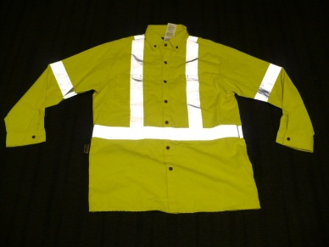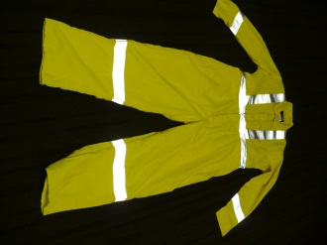

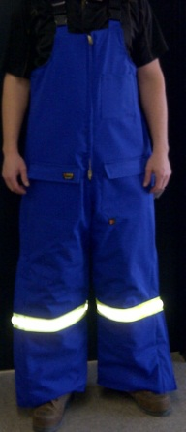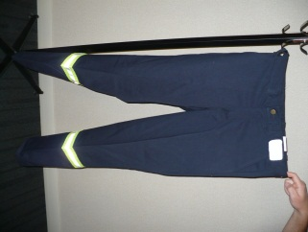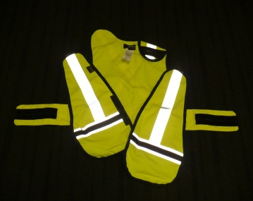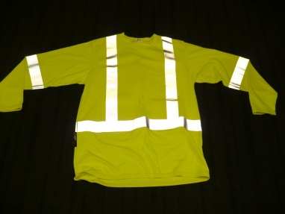

### Requirements for CSA Class 1 High Visibility Clothing

|  |  |
| --- | --- |
|  | Basic harness or stripes/bands over the shoulder(s) and encircling the waist. Background material must be at least 0.14 square meters of bright or fluorescent color.  Retro reflective or combined-performance material used in conjunction with background material of 0.10 square meters and no less than 50 mm wide.  Examples of Class 1 High Visibility Clothing: |
|  |  |

Machine generated alternative text: 5Ide-by-ide
Iluorestent Mid
retroreflectiw
stflpeslbands
Non4Igh-vtIIIty material
(tue)
Stde-by-tide retrorefiectivefluorestent stIes:
(enlargecfl
I I’ ‘
Figure 11.2
(lass 1 — [R (overalls

Machine generated alternative text: Fr w
Bach view
-—
(dr ar wflRm)
rlt.m flpabin
(AuorciUbijit armnJ.
ar fua cal/bi*I ydbw
ikan,ttra rntc 
Figure 11.1
Class 1 — Harness and striped apparel
•. .-,á:.IIt mll
r1’)F 
x f.cr nth.ht ‘Ii)
N

Machine generated alternative text: Fr w
Bach view
-—
(dr ar wflRm)
rlt.m flpabin
(AuorciUbijit armnJ.
ar fua cal/bi*I ydbw
ikan,ttra rntc 
Figure 11.1
Class 1 — Harness and striped apparel
•. .-,á:.IIt mll
r1’)F 
x f.cr nth.ht ‘Ii)
N

### 

### Requirements for CSA Class 2 High Visibility Clothing

|  |  |
| --- | --- |
|  | Full coverage of upper torso (front, back, sides, and over the shoulders\*). Refer to the CSA standard for an alterantive style for bib.  Retro-reflective or combined-performance material used in conjunction with background material of 0.13 square meters and no less than 50 mm wide.  Examples of Class 2 High Visability Clothing:  Machine generated alternative text: [xamples of alternative materials Figure B.3 Class 2 — Vest High-visibility material (fluorescent/bright orange /çOr fluorescentlbilght yellow) eLroret1ecflve strlpesfbands (silver or white) \ , of ‘— con1blnedpecfoIrnance retroreflecuve stripes/bands (fluorescent/bright orange or fluorescent/bright yellow)  Machine generated alternative text: Front view Combrned..p1o(Tnanc retrorñectlve strlp&bands (fiuorscn1Jbnit orange / or fluoroscenh/bl41t ycllow) orefiectlv strlpQsfbands (slIver or wtte) Optional arm bads Back view High-visibility matrlaI (t1uorcentJb,1t orange or fluorescenhJbrIit yoliow) Fxampl of alternative materials Figure 8.4 Class 2 —Jacket |

### Appendix C – Filter Lenses for Protection against Radiant Energy

|  |  |  |  |
| --- | --- | --- | --- |
| **FROM ARC WELDING** | | | |
| 1. Operations | Electrode Size  (1/32 inch) | 1. Arc Current   (AMPS) | 1. MinimumProtective Shade\* |
| 1. Shielded metal arc welding | Less than 3  3 - 5  5 -8  More than 8 | Less than 60  60 - 160  160 - 250  250 - 550 | 7  8  10  11 |
| Gas metal arc welding and flux cored arc welding |  | Less than 60  60 - 160  160 - 250  250 - 500 | 7  10  10  10 |
| Gas Tungsten arc welding |  | Less than 50  50 - 150  150 - 500 | 8  8  10 |
| Air carbon Arc cutting | (Light)  (Heavy) | Less than 500  500 - 1000 | 10  11 |
| Plasma arc welding |  | Less than 20  20 - 100  100 - 400  400 - 800 | 6  8  10  11 |
| Plasma arc cutting | (Light)\*\*  (Medium)\*\*  (Heavy)\*\* | Less than 300  300 - 400  400 - 800 | 8  9  10 |
| Carbon arc welding |  |  | 14 |
|  |  |  |  |
| **FROM GAS WELDING** |  |  |  |
| Operations | Plate Thickness - Inches | Plate Thickness - mm | MinimumProtective Shade\* |
| Gas Welding:  Light  Medium  Heavy | Under 1/8  1/8 to 1/2  Over 1/2 | Under 3.2  3.2 to 12.7  Over 12.7 | 4  5  6 |
| Oxygen Cutting:  Light  Medium  Heavy | Under 1  1 to 6  Over 6 | Under 25  25 to 150  Over 150 | 3  4  5 |

\*As a rule of thumb, start with a shade that is too dark to see the weld zone. Then go to a lighter shade which gives sufficient view of the weld zone without going below the minimum. In oxy fuel gas welding or cutting where the torch produces a high yellow light, it is desirable to use a filter lens that absorbs the yellow or sodium line in the visible light of the (spectrum) operation.

\*\*These values apply where the actual arc is clearly seen. Experience has shown that lighter filters may be used when the arc is hidden by the work piece.

### Appendix D - Glove Selection

|  |  |
| --- | --- |
| Purpose / Objective | To establish guidelines for the selection of gloves to further minimize the risk of injury to the hands. |

|  |  |
| --- | --- |
| Personal Actions | Recognize the potential causes of hand and finger injuries.  * Striking against or struck by an object. (Wrench slips off a nut, improper use of tools). * Caught in, on or between an object. (Handling heavy objects, pinch points). * Contact with chemicals, electrical current or extreme temperatures. (Lab environment, sample collection) * Rubbed, abraded or penetrated by an object. (Contact with a moving belt, lumber with a nail protruding) * Reaching into “blind spots” (Engine compartments, pails of material)  Inspect your job for hazards.  * Look for existing and unexpected hazards that may affect your hands or fingers.  Hand and Finger Safety  * Plan the work activity and select the best way of performing a job. * Follow all safety rules and procedures. * Wear the correct type of hand protection. * Keep your mind on the task when performing the activity. * Continually watch for potential pinch points. * Only operate equipment with guards in place. * Be prepared for the unexpected by being alert for changing or unusual conditions * When you are finished your work, leave your work area in a safe condition. * Lacerations can occur at any time when using a knife; remember always cut away from your body. * Never attempt to clean or adjust a moving piece of equipment. Follow lockout procedures. * Never reach into a “blind spot.” * Always watch for pinch points. * Avoid putting your unprotected hands into materials that have the potential to cause skin irritation or dermatitis. * Remove your gloves if there is a possibility of entanglement. * Do not wear jewelry (rings, bracelets, etc.) when working in an area that requires PPE. * Always inspect your gloves for damage before using. * Always use the proper tool correctly for the job. |

|  |  |
| --- | --- |
| Hand and finger hazards in the workplace | Identify potential hazards or energy sources that may cause hand or finger injuries such as:Mechanical Hazards  * Chains, gears, rollers, wheels, spiked or jagged tools, edges that can catch and tear, shearing, chopping and crushing, cutting tools such as knives, falling objects, etc.  Heat and Cold Hazards (Temperature extremes)  * Sparks, steam, hot or cold pipes and surfaces, welding, compressed gases, production process, or the environment.   icon_note.png Note: When the temperature of the hand or finger drops below 15° C or 59° F they become insensitive and the probability of an injury increases. Chemical Hazards  * Degreasers, metal dyes, and inks, plant and animal oils, cleaning solutions, process chemicals, fuels, acids, corrosives, etc.  Blood Borne Pathogen Hazard  * Hands may be exposed to contaminated materials that may cause infection.   icon_note.png Note: Always have hand or finger injuries cleaned and treated immediately. Abrasions: (loss of skin)  * Abrasions occur when skin is rubbed away by friction of belts, sanders, grinders and rough materials. Broken skin allows easy entry of harmful or infectious substances.  Lacerations: (cuts)  * Lacerations happen when contacting dull or sharp cutting tools, objects or materials with jagged edges.  Puncture Wounds  * Puncture wounds are caused when pointed objects pierce the skin and deeper tissues. (glass ,nails, sharp objects)  Repetitive Motion Hazards: (White Finger or Carpal Tunnel Syndrome {CTS})  * White Finger is caused by vibration that is passed on to the hands and fingers from working with vibrating power tools. Use of chain saws, air hammers, air chisels, jackhammers, etc. for extended periods will increase the chance of developing this. * Carpal Tunnel Syndrome (CTS) is the damage to the nerve that runs through the wrist. CTS are caused by work tasks that require prolonged and repetitive bending or twisting of the wrists. (Painters, bagging operators, are examples of those that could be affected by this condition.) |

|  |  |
| --- | --- |
| Hierarchy of Controls | When performing work that involves the use of your hands and fingers consider the hierarchy of controls to see if the task can be eliminated, if a substitution can be used or if an engineering control can be implemented. Examples are:   * Plan the work activity and select the best way of performing a job (automation). * Operate equipment with guards in place (table saws, grinders). * Use tools or materials that remove your hands or fingers from the line of fire i.e. push sticks, taglines |

|  |  |
| --- | --- |
| Glove Selection | **General Requirements:**   * Workers are required to wear gloves as per the Mosaic PPE program * Workers will consult standard operating procedures, job hazard analysis, task safety analysis or any other relevant documents that provide information on the appropriate glove to wear for the task/tasks being performed. More than one type of glove may be required to complete the task/tasks. * Should the above mentioned documents not provide sufficient information on the appropriate gloves to wear, a hazard assessment shall be performed to determine which gloves are necessary for the specific risks workers may encounter and the findings of the assessment recorded on the hazard assessment form (FLHA, FLRA, Safe Work Plan, SLAM Risk) * Based on the findings from the hazard assessment a glove selection guide (sample provided in Appendix D-1) can be used to determine what the appropriate glove for the particular task is. * Workers are responsible to select and wear the appropriate gloves that provide the hand protection required as per the assessment (reference Appendix D-2 for selection assistance). * Should you require assistance in selecting a glove for a unique hazard consult your Supervisor or Safety Professional   sign_warning.png ***Warning:*** Additional or specialized gloves required in other programs shall be worn to provide adequate protection from hazards that can cause injury or impairment in a function to any part of the hand through absorption or physical contact. Some trades such as welders, electricians, sand blasters, painters etc. may have to don additional or specialized gloves i.e. electricians using rubber gloves under leather (double gloving). |

**Appendix D-1 – Glove Selection Guide**

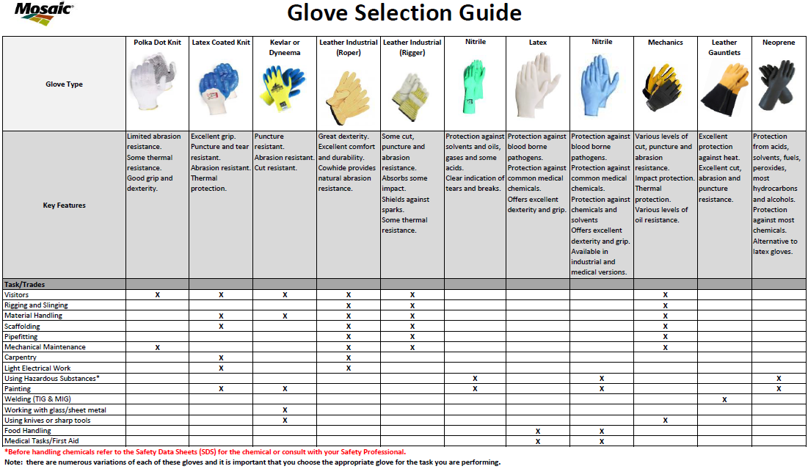

**Appendix D-2 – Glove Types and Construction**

This document contains the basic information regarding the different glove styles, construction, and types available. It is no means a complete guide to glove selection but merely a basic overview of the different options available.

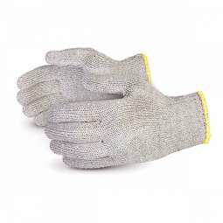**STRING KNITS**

A ‘string knit’ is a knitted glove. This designation is one of three possible types of glove construction. The other two are cut and sewn, and dipped. It is a category that overlaps

many others, like palm-coated, supported (dipped) gloves, heat-resistant, and cut-resistant styles. They are knit from a variety of materials, such as cotton, polyester, nylon, Kevlar®, Dyneme®, or combinations of these. Some styles incorporate materials such as carbon filament, stainless steel or glass which all bring different resistant attributes to the gloves for abrasion, heat, cut, puncture, flame resistance,

etc.

The materials used include 100% cotton, cotton/polyester blends, nylon, nylon-carbon (for anti-static applications),

Raggwool, Kevlar® and Dyneema® (cut resistant), Rhovyl® (flame retardant), to name a few. The yarns vary in weight and the thread-count per inch may be adjusted to offer a tighter weave for greater dexterity and higher degrees of protection from dirt and particles.

FEATURES and BENEFITS

* Machine-knit, seamless construction provides hand-hugging comfort and fit.
* Ambidextrous or reversible, string-knit gloves eliminate sorting problems and reduce glove replacement costs.
* String-knit gloves conform to hand for better fit and allow skin to breathe.

COMMON APPLICATIONS

* General-purpose, popular in warehousing, parts handling, assembly, etc.
* Many styles are CFIA approved for food processing.
* Popular as a glove liner under liquid-proof gloves.

AVAILABLE FEATURES

* A variety of densities or gauges (string thickness) provide user with differing degrees of dexterity. Density refers to the tightness of the weave. The higher the gauge, the more dexterity it provides (i.e. 7 gauge is the most open knit, 18 gauge the tightest knit).
* Common weights are light, medium, and heavy.
* Cotton/polyester blend is the most popular and launders the most favorably.
* 100% polyester or 100% nylon is the solution if “lint” is an issue.
* 100% cotton is best where low to medium heat is an issue.
* Rhovyl® or Kevlar® is the solution if flame resistance is an issue.

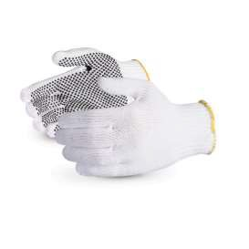**DOTTED STRING KNITS**

Dotted string-knit gloves use string-knit gloves as “shells” or liners. A coating of PVC, or nitrile dots are silk-screened onto the glove to improve grip and abrasion resistance.

FEATURES and BENEFITS

* Knit shell provides all the same benefits as uncoated versions.
* PVC dot and brick patterns provide excellent grip and prolong glove life due to increased abrasion resistance.
* PVC palm-coated pattern provides good puncture resistance and reduced particulate infiltration.
* RT Reinforced styles have a PVC coating on the thumb crotch and finger tips (where gloves most often wear out first).

COMMON APPLICATIONS

* General-purpose abrasion protection.
* Very popular in automotive industry, warehousing, parts handling, assembly, etc.

AVAILABLE FEATURES

* Glove shells are available in a variety of gauges and weights. Gauge refers to the tightness of the weave. A regular liner weighs around 600 grams/dozen. A heavyweight liner weighs around 900 grams/dozen.

**PALM-COATED GLOVES**

Palm-coated gloves use string-knit gloves as ‘shells’ or liners. These gloves are coated with PVC, nitrile, latex, polyurethane (PU), using a dipping process. They offer great dexterity, durability and some liquid protection. All palm-coated gloves provide a great grip dry. For wet 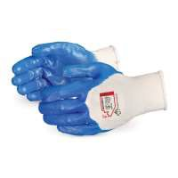or oily grip, a foamed material is recommended, as the foam channels away liquid and prevents a slick from forming on the surface of the glove.

FEATURES and BENEFITS

* Most coated gloves provide some liquid resistance.
* Coated gloves are available in smooth, rough, foam and crinkle finishes, each offering varying degrees of grip.
* Latex crinkle-finish gloves provide outstanding grip, as well as a light degree of cut and puncture resistance. Latex is not recommend for applications involving oil because latex degrades in oil (i.e. metal stamping).
* Nitrile provides outstanding grip, abrasion resistance and is a good choice for handling oily parts. Nitrile is the most popular choice for coated gloves.
* PU coatings are generally regarded as the softest and most comfortable coating. They are also very “clean”, making them a good choice for electronics handling and automotive paint applications.

COMMON APPLICATIONS

* Latex crinkle-finish gloves resist cuts and punctures and offer good abrasion resistance. They are commonly used for glass-handling and sheet-metal applications.
* PU coatings provide excellent dexterity with very little lint. They are good in material-handling applications such as electronics assembly.
* Nitrile-foam gloves are popular in oily, slippery applications.
* PVC-coated gloves are particularly good in adhesive applications, such as furniture manufacture. They are also well suited for many general purposes, and assembly applications.

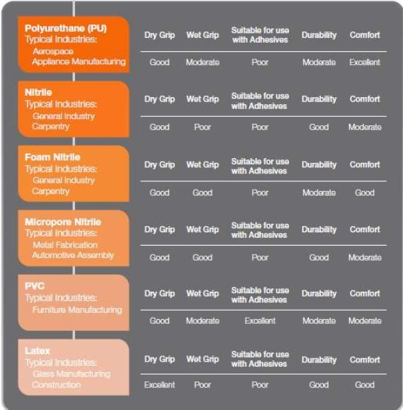

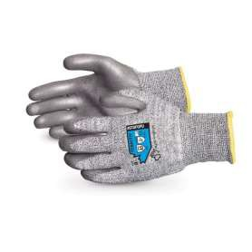**CUT-RESISTANT GLOVES**

Cut-resistant gloves and sleeves are produced much the same way that string-knit gloves are. However, they feature high-performance yarns to enhance cut and abrasion resistance.

FEATURES and BENEFITS

* Knit pattern provides all the same benefits of string knits (i.e., breathability, dexterity, etc.).
* Many styles are available with PVC, latex or nitrile coatings for improved grip and abrasion resistance.
* Composite blends of Kevlar®-steel, Dyneema®-steel, Dyneema®-fiberglass are also available. To achieve high levels of cut resistance, a composite yarn is required.

COMMON APPLICATIONS

* Food processing, glass handling, automotive manufacturing, metal stamping.
* Any application where there is a high risk of cuts and lacerations.
* Lighter-weight styles used as a glove liner to provide extra protection.
* Market place is heading towards most general duty jobs having some sort of cut resistance.

AVAILABLE FEATURES

* Cut-resistant sleeves are available in various lengths from 10-24 inches and are made from both Kevlar® and Dyneema®.
* Same points regarding string knit gloves apply, the higher the gauge the more dexterity.
* Secondary factors like grip (select proper coating) or resistance (heat, abrasion, etc.) determine optimal material.
* Cut resistant gloves should be paired with cut resistant sleeves to protect wrists and forearms.

**Important note**: yarn strength does not necessarily equal cut resistance.

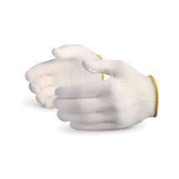**WOVEN-COTTON WORK GLOVES**

Cotton work gloves have been available to workers for decades. The process has remained largely unchanged since they were first developed.

The fabrics include 100% cotton and cotton/ polyester blends. Many styles are available to fit the needs of many varieties of jobs. This style of glove is decreasing in popularity since the invention of the seamless-knit glove, which fits the hand better and is generally less expensive.

FEATURES and BENEFITS

* Canvas, single-palm gloves are one of the most popular work-glove styles. They are made from one layer of material. They are available in a variety of fabric weights and provide a very cost- effective, versatile, hand-protection solution that is widely accepted by the user.
* Canvas gloves with PVC dots offer improved grip. Dots prolong the usable life of the gloves.
* All-cotton styles provide some degree of heat resistance and abrasion protection.
* Double-palm gloves provide superior abrasion resistance and moderate heat protection while sacrificing minimal dexterity.
* Hot-mill styles are made of a variety of layers of material to provide greater heat protection than single-layer gloves. Burlap liners create pockets of air between the cotton layers to improve insulation characteristics.

COMMON APPLICATIONS

* Canvas styles are used in any general application such as maintenance, warehousing, material handling and agriculture.

AVAILABLE FEATURES

* Canvas styles are available with band-top cuffs, gauntlet cuffs, and knit-wrist cuffs.

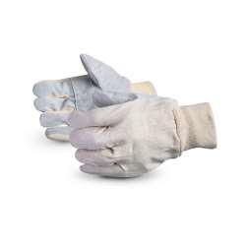**LEATHER PALM GLOVES**

Leather-palmed gloves are made using traditional cut- and-sew methods, which are labor intensive. Leather gloves offer protection from rough objects, heat, sparks and abrasion. Generous sizing, a variety of cuff designs and choices in leather quality make leather palms one of the most widely used gloves in industry.

FEATURES and BENEFITS

* Manufacturers offer several grades of split leather, top-grain cowhide, premium pigskin and goatskin for every application.
* 2 ½” safety cuff provides user with protection over the wrist, as well as ability to quickly discard glove in problem situations.
* ½” gauntlet cuffs extend that safety further up the forearm.
* Kevlar®-stitched styles prolong life of glove by providing additional heat protection, as well as additional wear.
* Rubberized cuffs provide abrasion resistance in the toughest of applications.
* Knit-wrist style keeps particulate matter out of glove.

COMMON APPLICATIONS

* Popular in rugged-duty applications such as farming, foundry, lumberjacking, mining, and heavy-machine operation. Handling wire, wire rope, pry bars, railroad bars, or when hands/fingers could be pinched between objects.
* Top-grain styles provide superior abrasion resistance and usually last longer than split styles.
* Goatskin is most expensive, but is the strongest and thinnest leather, providing users with the best dexterity of any leather-palmed glove.

AVAILABLE FEATURES

* Many styles are available in double-palm versions. Be sure to note the difference between a patch palm (small pieces sewn together) vs. a true double palm.

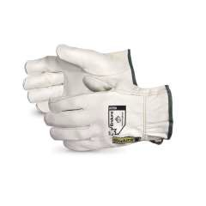**DRIVERS AND ROPER GLOVES**

Leather drivers gloves offer many of the durable aspects of leather-palmed gloves coupled with better fit and dexterity compared to traditional leather fitters glove. Various leather options and slip-on styling create comfortable gloves for the most rugged applications. The term drivers and ropers gloves are commonly used interchangeably but while they look the same, there is a difference in seam location which does affect durability.

FEATURES and BENEFITS

* Drivers gloves feature slip-on styling to provide good fit and comfort.
* A variety of leathers are used to make drivers gloves:
  + Top-grain cowhide provides the best abrasion resistance and puncture resistance.
  + Split cowhide provides good abrasion resistance.
  + Top-grain pigskin is a very pliable leather that will retain its softness even after being soaked in water and dried out.
  + Goatskin is one of the most durable leathers available. Very thin but very strong, goatskin has natural lanolin, which helps avoid skin chafing. The dexterity of goatskin is the best of the available leathers.

COMMON APPLICATIONS

* Used in construction, machine operation, utility work, farming, and many other general applications.
* Pigskin is preferred in wet applications, as it will return to its original pliability after getting wet.
* Goatskin is used where tactile sensitivity and resistance to abrasion are of key importance.

AVAILABLE FEATURES

* American styles have shirred wrist for snug fit. Canadian styles have a snap closure.

**FITTERS GLOVES**

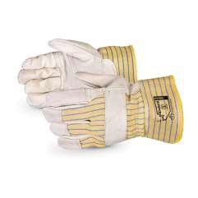The fitters glove is typically what most people think of when they talk about a work glove as it has been in use for many years. It is typically a leather finger and palm construction that protects against scrapes and abrasion. It is still very popular because of its ability to resist abrasion or how it can slip off when unneeded. The fitters glove is often misused as a cut resistant glove.

FEATURES and BENEFITS

* High abrasion resistance and typically some sort of puncture resistance due to the leather palm.
* Full grain leather versions can provide water and oil resistance.
* Gunn Cut styles keep stitches and seams away from high wear areas to increase durability.

COMMON APPLICATIONS

* Used in construction, maintenance, utility work, farming, and many other general applications.
* Lined or unlined versions available for either winter or summer use.
* Cowgrain styles are heavier weight for increased durability or Pigskin for more breathability and its ability to return to its original softness after becoming wet.

AVAILABLE FEATURES

* Different gantlet material types and length to create added forearm protection.
* Fingertip and knuckle bar straps to provide wear resistance to the tops of fingers and back of hand.
* Kevlar liners at different cut ratings to provide cut protection.

**LEATHER TYPES**

Gloves come in many different levels of protection, dexterity, and comfort. Leather is a favorite choice for gloves. It's tough. It has good abrasion and puncture resistance. It breathes and conforms to the hand with time. The location and cut of leather that comes from cowhide makes a big difference, especially with split leather (the internal side of the hide). Side split is the most durable and best quality but also the most expensive. Shoulder split is also quite durable but slightly more economical. Belly split is the most economical and least durable cut.

**Please Note** while leather is tough and durable; it has no cut resistant properties.

**FULL-GRAIN** leather, made from the finest raw material, are clean natural hides which have not been sanded to remove imperfections. Only the hair has been removed. The grain remains in its natural state which will allow the best fiber strength, resulting in greater durability. The natural grain also has natural breath-ability, resulting in greater comfort for clothing. The natural Full- Grain surface will wear better than other leather. Rather than wearing out, it will develop a natural "Patina" and grow more beautiful over time. The finest leather furniture and footwear are made from Full-Grain leather. Grain provides durability, dexterity and water and oil repellency.

**TOP-GRAIN** leather is fuzzy on one side and smooth on the other. The smooth side is the side where the hair and natural grain used to be.

**SPLIT SKIN** leather that has had the grain completely removed or is an interior split of the hide/skin. During the splitting operation the grain and drop split are separated. The drop split can be further split (thickness allowing) into a middle split or a flesh split. In very thick hides the middle split can be separated into multiple layers until the thickness prevents further splitting. The strongest suedes are usually made from grain splits (that have the grain completely removed) or from the flesh split that has been shaved to the correct thickness. Split is "fuzzy" on both sides, less durable than top-grain and cheaper because many pieces of suede can be split from a single thickness of hide, whereas only one piece of top-grain can be made. Split Leather is also durable and is more economical.

**COWHIDE**: Offers comfort, durability, good abrasion and heat resistance.

**PIGSKIN**: Offers comfort, and extra breath-ability. Withstands moisture without stiffening.

**DEER SKIN** is one of the toughest leathers. It is extremely soft and supple with excellent dexterity.

**GOATSKIN:** High natural oil content makes goatskin very soft and pliable. Excellent tear resistance even when very thin.

**HORSEHIDE:** Tough and durable, yet very comfortable.

**ELKSKIN:** Elk split is the strongest leather out there, and offers excellent strength and abrasion resistance because it is thicker than regular split skin. (1.5 mm. thick, compared with 1.1 mm. thick for cow split).

**SHEEPSKIN:** Used where optimum dexterity and touch sensitivity are needed.

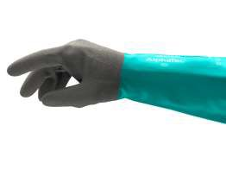 **CHEMICAL-RESISTANT GLOVES**

Unsupported liquid-proof gloves are made when ceramic molds are dipped in latex, nitrile or neoprene. Supported gloves are manufactured by dipping a shell of either jersey or interlock knit into a dipping compound. Latex resists bases, acids, alcohols, and diluted solutions of most

types of chemicals. Nitrile offers greater protection against animal fats (particularly red meats), oils, many solvents, esters and greases. Nitrile is highly resistant to snags and punctures. Neoprene has better resistance to oils, acids,

caustics, and solvents than nitrile, however neoprene is less resistant to snags and puncture. PVC provides protection against many acids, caustics, bases and alcohols. PVC-coated gloves offer good abrasion resistance.

Chemical gloves can also be offered with cut and puncture resistance linings as well as different grip options.

FEATURES and BENEFITS

* Full line of nitrile, latex, vinyl, PVC and neoprene chemical-resistant gloves.
* Rough grips include, sandblast, recessed-diamond, roughened-sandblast, raised-diamond, honeycomb and pebble.
* Unlined styles are generally powder-free.
* Most unlined styles are flock-lined (cotton added to the inside) for easy on-and-off, as well as for perspiration absorption.
* Nitrile, latex, PVC and neoprene offer exceptional chemical resistance without sacrificing dexterity.

COMMON APPLICATIONS

All styles are used in food processing, janitorial, sanitation and maintenance industry. Popular for any application that requires resistance to caustic chemicals such as fertilizer, battery acid, animal fats, etc.

**Please note: always refer to a chemical-resistance chart when selecting chemical gloves.**

Chemicals interact with the glove material itself which can break down and eat away at the material to cause a hole in the glove (penetration) or they can move through the material itself (called permeation, think water and osmosis) to contact the hand. It is important to select chemical gloves by matching the glove material with the chemical products being handled and the expected length of exposure.