Potash Product Pile Management Program

|  |  |  |  |
| --- | --- | --- | --- |
| **Location/Applicability:**  Potash Business Unit | | **Document Owner**  Director, Health & Safety | |
| **Effective Date**: August 1, 2022 | **Review Due Date**: August 2029 | | **Originating Department:**  Health & Safety |

**Table of Contents**

**Purpose 2**

**Scope 2**

**Responsibilities 2**

**Pile Management General**

Access to Storage Areas  **2**

Reclaiming Product **3**

**Product Set Up 4**

**Equipment**

Working with Loaders **5**

Use of Loader with a Probe (Probing) **5**

Use of Trackhoe **6**

Use of Push Cat/Dozer **7**

**Definitions 7**

1. Purpose

It is the responsibility of Mosaic to ensure the safety of all employees and contractors. This program is intended to provide basic guidelines to ensure potash product pile warehouse activities are handled in a manner that prevents injury and/or property damage. This program was developed with the intention of minimizing risk and exposure for individuals working with these piles.

1. Scope

To implement a comprehensive safety program ensuring safe work around potash product piles (also referred to as product piles or piles throughout) for all Mosaic Potash sites. This program shall be used as a guideline to create site level procedures while working with piles of product or raw ore. For any facility specific hazards not addressed in this program, a site specific safe work plan and procedures are to be approved by the site management.

1. Responsibilities
   1. The NAB Health and Safety Department is responsible for maintaining this program.
   2. The Training Department is responsible for providing resources to assist facilities with training personnel in best safety practices.
   3. Facility Managers are responsible for the implementation of this program at their facilities.
   4. Mosaic personnel and contractors performing the work described in this program are responsible for understanding and following safe work practices outlined in this program.
   5. Each site is responsible to ensure all personnel are aware of the hazards associated with product piles and work in and around storage buildings.
2. Pile Management General:
   1. **Access to Storage Areas**:
      1. Access to product storage areas (also referred to as warehouses) shall be controlled to limit risk to personnel and others who do not have a need to be in the area of moving equipment. Only trained or escorted personnel may enter the warehouse, but permission from the area owner is still required as per site procedures.
      2. All personnel with access to the warehouse shall be properly trained and aware of the moving equipment, pile conditions and work occurring in the building. The safety processes, equipment and security should be relevant to the type of risks in the specific situation.
      3. When driving a vehicle into a warehouse, the vehicle’s headlights must be turned on, horn shall be honked and site specific procedures relating to entry must be followed.
      4. Personnel may not enter a warehouse in which there is mobile equipment operating without permission from the operator. Once the operator has stopped the equipment and permission has been granted, the personnel may enter but a flashlight or headlamp must be in the on position while in the warehouse on foot in order to be more visible.
      5. Personnel shall not walk on product piles without an approved Safe Work Plan.
      6. Personnel must maintain a two-to-one distance from product piles that have a straight face, overhang, or large lumps that might fall.

* 1. **Reclaiming Product:**
     1. Product shall be reclaimed from multiple angles in the product pile to prevent unsafe conditions from occurring.
     2. If an unsafe product pile exists refer to table below:

|  |  |
| --- | --- |
| **If an unsafe product pile exists, the following steps must be taken:** | |
| 1 | The doorway of the warehouse must be taped off with appropriate barricade. The barricade must include:   * The name of the personnel performing barricading, * The date and reason for barricading |
| 2 | The area owner must be contacted and informed of an unsafe pile |
| 3 | Barricade tape must be left in place until the unsafe condition no longer exists, such as:   * The product has been blasted down * The product has sloughed down * Sufficient product has been transferred onto the overhung area and the overhang no longer exists |
| **If an unsafe product pile is created when reclaiming, the following steps must be taken:** | |
| 1 | The equipment operator must not step outside his/her machine in the vicinity of the unsafe pile (overhang, straight face, and large lumps). |
| 2 | If the vertical face is soft and can be safely knocked down with the bucket of the loader, the vertical face should be eliminated in this manner. At no time should the equipment operator attempt to remove the vertical face if there is potential for the product to come down onto the cab of the equipment. |
| 3 | The limit for working a vertical face is the fully extended loader equipment plus 2 metres (6.5 feet). Once the limit has been reached, reclaim must be stopped in that location. Reclaim in the same warehouse is permitted but must be in a different location until the unsafe condition no longer exists. |
| *Never enter a warehouse for convenience travelway. | |

1. Product Set Up
   1. **Ongoing Monitoring and Proactive Management** - Prevention is the key to managing set-up conditions. If issues are identified early, the pile can be worked immediately to keep the product in free-flowing form.
   2. **Managing Set-Up conditions** If lumps and vertical face are noticed in the warehouse and product is no longer free flowing the following steps should be taken:
      1. Ensure all personnel, contractors and management are aware of the potential situation – proper barricading should be immediately posted to notify others of the risk.
      2. Prior to taking any action to correct the product pile issue the condition of the pile must be assessed. Please refer to checklist in below table to assess pile condition.

|  |  |
| --- | --- |
| Product Pile Assessment Checklist | |
| 1 | Is there a significant product vertical face existing? |
| 2 | How hard is the product - can it be easily broken up or does it require significant effort? |
| 3 | Do larger visible lumps / boulders exist in the pile? |
| 4 | How high up is the product set up? Is it higher than the cab on the equipment? |
| 5 | How much product is remaining in the warehouse? |
| 6 | Is there evidence of undermining (the bottom of the pile has been removed but product above has not, creating an overhang)? |

* + 1. No work should occur without an approved safety plan in place.
    2. Based on the condition of the pile and product, appropriate mitigation measures shall be implemented.
    3. Frequently inspect the pile condition and evaluate the situation to ensure the safest course of action for the operator and equipment.
    4. If the product is easily broken up and the warehouse configuration and inventory allow, equipment operator may be able to address the pile and force product to flow by moving it around in the warehouse pulling from all angles in the face of the pile – equipment operator shall immediately stop if any indication of undermining occurs.

1. Equipment:
   1. **Working with Loaders:**
      1. Personnel/contractors shall not leave the pile in an unsafe condition. They are not to undermine a pile.
      2. When reclaiming, the operator of the front-end loader must always be aware of changing pile conditions such as straight faces, overhangs, and large lumps. If any of these conditions exist or are created, the operator must work in another area of the pile until the hazardous conditions have been corrected
      3. When reclaiming keep the machine on level ground.
      4. Start and stop smoothly when carrying a load.
      5. Keep a loaded bucket close to the ground for stability.
      6. Operate straight up and down slopes whenever possible (side hill operation can cause the machine to roll over).
   2. **Use of Loader with a Probe (Probing):**
      1. Given the high risks associated with probing a product pile, measures shall be taken to avoid injury to the operator or the surrounding building structure and equipment.
      2. The probe should be attached on the loader using proper procedures and properly secured.
         1. Ensure the procedure occurs on a flat surface.
         2. Look under and around the probe and bucket for damage and broken parts.
         3. Stay out of the line of fire when performing machine checks.
         4. Remove the probe by reversing the steps of the attachment.
      3. Additional care must be taken when operating the loader with the probe attachment due to the length and weight of the probe:
         1. When travelling with the probe attachment, keep the probe low to the ground.
         2. Travel as slowly as practicable and refrain from sudden steering corrections.
         3. A spotter shall be utilized to ensure clearance over potential obstacles and uneven surfaces.
      4. These steps must be used to bring the pile down using a mounted probe:
         1. Ensure the area is clear before beginning.
         2. Utilize the boom or bucket control to get desired height and angle of the probe.
         3. Probe the top sides of the pile (as high as can be safely reached or as necessary by the height of the vertical face). Work with the probe inward toward the center of the pile.
      5. It is critical to avoid probing in the middle of the pile as this will cause a dangerous situation that can create lumps in the center that tend to be much larger and more difficult to manage. The pile can shift suddenly causing an avalanche type situation.
      6. The product pile should be constantly addressed, and a vertical face should not be allowed to form any higher than the roof of the loader cab.
      7. The probe should be gradually inserted only far enough to disturb the pile, then proceed in a progressive manner.
      8. Slowly remove the probe and repeat as necessary.
      9. The probing process should be a series of several small probes and be repeated at various parts of the pile leaving a new face. Continue the process until safe conditions exist and product is falling.
      10. Larger lumps tend to stay on the probe as it is removed from the pile – be aware of this and avoid placing the loader in close proximity to the vertical face.
      11. In rectangular shaped bins where product is not stored at the typical angle of repose, probing has to begin in the center of the pile. It is not recommended to probe the sides near the walls or to create voids along the sides of the walls as stress on the bin walls can greatly impacted.

Figure 1 - Typical probe attached to a payloader

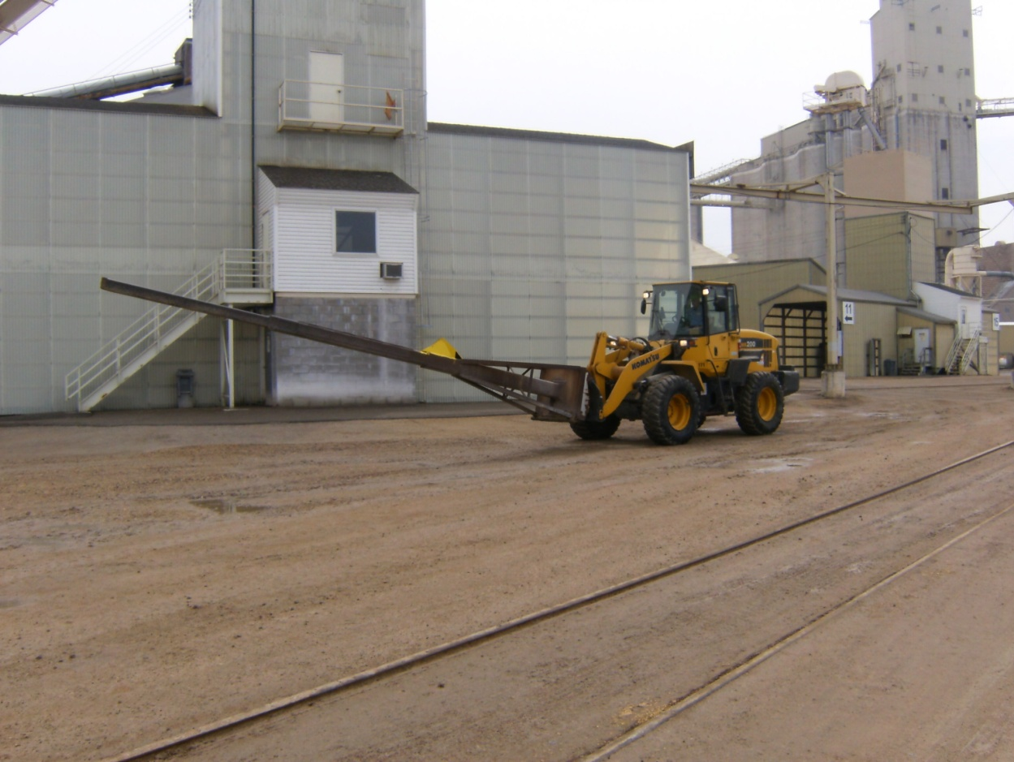

* 1. **Use of Trackhoe**:
     1. If the probe fails to breakdown the vertical face a trackhoe can be used.
     2. The trackhoe operator must be in radio contact at all times.
     3. Operator must be aware of the location of the tripper.
     4. If the top of the vertical face is too high to reach, the trackhoe operator must bench up to a safe height to be able to reach the top of the pile.
        1. The bench must be made twice the width of the footprint to sustain a solid footing while operating the trackhoe. The height of the platform will be dependent on the height of the peak that must be reached with a safe distance.
     5. When reclaiming a pile with a trackhoe these steps must be followed:
        1. Notify supervisor before beginning procedure.
        2. Approach the pile, keeping at a safe distance at all times.
     6. If unable to reach the top of the pile with the boom fully extended:
        1. A product ramp must be used.
        2. Consult with supervisor the intent to use a ramp.
        3. Construct a product ramp that is twice as wide as the trackhoe.
        4. Advance up the product ramp as desired.
     7. Dig a hole between the trackhoe and the face of the pile. This practice is used so that in the event that the pile does unexpectedly fall, it will fill the hole before reaching the equipment and operator.
     8. Raise the boom and slowly knock down the vertical face of the pile.
     9. Keep advancing the trackhoe until the face can be reclaimed in a safe manner with the loader.
     10. Optional equipment to be used in the eliminating of hazardous conditions of the pile should be a long reach excavator (65 foot reach).
  2. **Use of Push Cat/ Dozer:**
     1. Note: Potash piles may exhibit caking or setup that appears very stable; however, the material can return to a loose bulk state unexpectedly and without warning.
     2. Ensure the push cat/dozer always operates on top of a pile with sloped sides at a natural angle of repose. Never operate or stockpile above a semi-vertical, vertical, or undercut face due to the potential for material fall.
     3. When traversing or ramping up the side of a conical pile, always maintain a working shelf that is two times the width of the push cat/dozer in order to eliminate the risk of rollover.
     4. Do not attempt to dislodge or pull down a cracked face or lump that is vertically higher than the cab floor. There is substantial risk if such a lump were to rollover or past the bucket of the push cat/dozer.

1. Definitions
   1. Area owner: Employee who is in Production / Operations, Maintenance or Support and is accountable for the location. Examples include the Loadout/Reclaim Foreman or Supervisor, Coordinator or Superintendent.
   2. Avalanche: A large mass of product or material in swift motion downward in a pile.
   3. Vertical face: A very steep face occurring anywhere in the product pile.
   4. Pile/Product Pile: In this program is any product stored in a height greater than 10 feet (warehouse inventory)
   5. Peak: The top of the pile.
   6. Angle of Repose: The maximum angle to the horizontal at which a granular product will remain without sliding.
   7. Probe/Lance/Spear: A long metal instrument attached to a pay-loader to poke at a pile of product.
   8. Undermining/Cavity: The sloughing away of supporting material from under; this is a very dangerous situation.
   9. Product Storage Area / Warehouse: This is where product is stored.